
Performance Improvement Plan Policy V_1.0

ABC Company Document
Performance Improvement Plan Policy V_1.0

 | Prepared by | Reviewed by | Approved by
Name
Date | 17th August 2021 | 17th August 2021 | 17th August 2021
Version History
V_1.0 | Launch of Performance Improvement Plan Policy (PIP)

ABC Company Document
Table of Contents
- OBJECTIVE 3
- SCOPE 3
- DEFINITIONS 3
- POLICY OUTLINE 5
- PROCEDURES 5
  - Performance Improvement Process 5
    - Counselling 5
    - Formal Procedure: Invite the performance meeting 6
  - PIP REVIEW MEETING 7
- RESPONSIBILITIES 7
  - Employees 7
  - Manager 8
  - Account/ LOB Leadership 8
  - HR Business Partner 8
- RACI MATRIX 9
- PROCESS FLOW 9
- FREQUENTLY ASKED QUESTIONS (FAQ’S) 10

ABC Company Document

Objective
  - ABC Company seeks to foster Individual development culture to achieve strategic goal and ensure employee development through continuous learning.
  - The objective of this policy is to provide the proactive and progressive actions a manager may take when issues in employee’s performance, attendance, discipline or attitude / behavior are identified.

Scope
This policy is applicable to all the permanent employees of ABC Company India.

Definitions
Performance Improvement Plan (PIP) A Performance Improvement Plan (PIP) is the performance document which identifies the performance standard which the employee needs improvement, From Counselling through Termination. The manager uses the PIP to describe the performance, disciplinary, attitude/ behaviour issues, outline specific improvements that are needed, and provide a timeframe for improvements to be made. It includes a specific period (e.g., 30, 60, or 90 days) during which the employee’s performance, attendance, discipline or attitude/ behaviour must improve or a recommendation for necessary disciplinary action including termination may be made.

Internal Movement Any associate who is assigned to an account from the LOB bench is defined as Internal Movement

Gross Misconduct or Serious Negligence is defined as any behavior(s), action(s) or lack of action by an employee, that warrant(s) serious disciplinary action or acceleration of the PIP including, but not limited to:
- Negligence or failure to attend to customer needs that has the potential to cause harm to a customer, fellow employee, or any other external bodies.
- Insubordination, which is defined as refusal to carry out a specific, legal, and work-related directive or request issued by an appropriate manager.
- Inappropriate or unauthorized release, discussion, or disclosure of confidential information.

ABC Company Document

- Unauthorized possession, use, theft, or damage to property of the Organization and its internal and external stakeholders.
- Reporting to work under the influence of drugs and/or alcohol.
- Falsifying and/or omitting information on Organization records and/or requests for information, including but not limited to employment applications, time and attendance records.
- Violation of any law, policy, regulation, or practice, including those related to principles of customer service and/or the Code of Conduct.
- Excessive absenteeism, tardiness, or leaving the work area or Organization premises without prior permission of immediate supervisor. (Refer Attendance and punctuality {Policy.)
- Sleeping while on official working hours.
- Unlawful or improper conduct during official hours.
- Conviction of a crime, which may call into question the employee’s ability to properly carry
out the responsibilities of his or her position.

Counselling is defined as a formal conversation between a manager and an employee to inform him/her that an issue exists with his/her performance, attendance, discipline or attitude/ behavior and to detail the precise action needed by the employee to address the identified issues. It is often the first action taken in the Performance Improvement Process.

Written Warning is defined as a formal, documented discussion between a Manager and an employee used to inform him/her about his/her unsatisfactory performance, attendance, disciplinary or attitude/behaviour issues and to detail specific improvements that are needed. To address repeated and/or ongoing work-related issue(s).

Termination of Employment is defined as an involuntary permanent dismissal from the workplace when:
- An employee fails to improve his or her performance, attendance, or behaviour through a Performance Improvement Plan (PIP), or
- Immediately, without prior notice of PIP, in instances of gross misconduct or serious negligence or circumstances under which the supervisor, in consultation with HR Business Partner,

ABC Company Document

determines that the nature, frequency or severity of the work related problem warrants such action

Policy Outline
- Performance Improvement Plans is implemented when an employee’s overall performance rating is “Unsatisfactory”, or if the supervisor determines the employee’s current performance requires improvement after the supervisor has held prior discussions over counselling with the employee and has communicated expectations.
- When an employee’s attendance, discipline or attitude/ behavior is unsatisfactory, the supervisor will advise the employee of the issue(s) and give him/her an appropriate opportunity to improve to an acceptable level through the Performance Improvement Process. (e.g. does not meet the performance of the position, insubordination, creating hostile environment by inappropriate attitude etc.).
- When an employee is rated as below expectations or substantially below expectations in the annual PMS the HRBP along with the reporting manager will initiate the PIP in the portal and the reporting manager provides goals for PIP. These goals are to provide an opportunity to improve the performance to meet expectations in the consequent cycles.
- When PIP is initiated, the manager shall document the issue(s) and share the plan with the employee in a face-to-face/Virtual meeting. Should the employee’s performance, attendance, discipline or behavior fail to improve as specified by the PIP, the employee will be subjected to further action, up to and including termination.

Procedures

Performance Improvement Process

Counselling
Prior to the formal procedure being invoked, it is important that the issues of underperformance were discussed with the employee and the manager has attempted to resolve them over counselling. The manager shall maintain records of employee counselling before the formal process of PIP is initiated.

ABC Company Document

Formal Procedure: Invite the performance meeting
If the discussions or suggestions over counselling by the manager does not achieve the required standard of performance, then the manager shall reach HR Business Partner defining the need for the implementation for the formal procedure of PIP, The HR Business Partner gathers feedback and critically evaluates whether PIP shall be initiated.
Manager shall call for a formal meeting with the employee along with HR Business Partner and share the performance feedback with the employee and inform the employee on the need for initiating PIP. The meeting shall cover the following aspects
      - The specific performance/Areas where the employee did not met the required performance standards to be communicated to the employee.
      - Manager shall define and document the “Improvement Goals” in detail. The goal completion timelines are to be identified (The PIP timelines can be of 30, 60 and 90 days and cannot extend beyond 90 Days)
      - Post the meeting, HR Business Partner shares PIP users list to Portal team. Portal team initiates the PIP on portal.
      - Manager shall define a minimum of 3 goals in the portal, there is no capping on the maximum number of goals, once the manager submits the goals, a system generated email is sent to the employee notifying about the PIP initiation.
      - Employee shall review and update the status against each improvement goal in portal, by selecting the drop downs in the portal to reflect the status.
      - Employee shall submit regular status on the improvement goals in portal, manager shall review the same and provide regular written feedback during PIP, on a weekly / fortnightly basis depending on the review period.
      - Once employee completes the goals, Manager shall review all such goal completion along with employee and HRBP.
      - The consequence of Success or failure to improve the performance with in the review period shall be updated in the system by mentioning overall closure comments/summary.

ABC Company Document

PIP review meeting
A PIP review meeting will be held at the end of the review period. The potential outcome of the meeting are
Satisfactory Performance: Where the manager assesses that the employee has achieved the required standards and no further action will be taken. The PIP is closed.
Partial Improvement: where the manager assesses that the employee is improving his performance and the required performance standard will be attained shortly, the review period may be extended.
No Improvement: where the manager assesses that there is no improvement shown by the employee despite of all the opportunities provided. The employee will be subjected to further action, up to and including termination. The organization reserves the right to determine what actions are appropriate and in what order such actions are to be taken depending on the facts and circumstances of the situation.
Supervisor, basis the outcome of the review of PIP as per timeframe, the necessary action will be recommended by CSD/DM/LOB, actions could be extension of PIP or termination.

Responsibilities

Employees
- Ensuring that all the employees understand and perform to the standards required for their role
- Understanding that if their work performance is below the required standard for their role, managers will be obliged to address this.
- Receiving feedback in a constructive way from managers and considering it as a way for improvement
- If the employees have any concerns arising due to personal or professional factors impacting their level of performance, bringing it to their managers attention.
- Actively engaging and making all the reasonable efforts to positively improve their performance with the support of their managers, when the policy is implemented for any employee.
- Employee shall ensure that, the status for the improvement goals in the system are updated regularly.

ABC Company Document

Manager
- The required performance standards for the role are clearly communicated and understood by the employee. The manager shall provide SMART Goals.
- Supervisor shall hold regular review meetings and provide ongoing feedback and support required and document the discussions.
- To help employees to reach and maintain the required standard of performance for their role, suitable support, if needed, training and development opportunities can be provided.
- The Manager must use a PIP to document any action taken in the Performance Improvement Process.
- Consultation with Human Resources is strongly advised prior to commencement of Performance Improvement Plan beyond Counselling and in case of termination due to PIP failure.

Account/ LOB Leadership

For Internal Movement:
- In case of Internal Movement, if the employee is under performing within 3 months of assignment, the LOB should determine the need for PIP or Job Rotation as required.
- However, in a case of internal movement where employee has spent more than 3 months in the account, then the account leadership has to determine and own the PIP.

HR Business Partner
- The HR Business Partner shall critically evaluate the feedback provided by the manager and suggest whether PIP shall be initiated or not
- HR Business Partner ensure that the employee is given interim feedback during the course of PIP
- The HR Business partner shall govern the process and suggest the manager or employee when needed, regarding the process to be followed effectively.

ABC Company encourages supervisors to use proactive and progressive action whenever possible to improve performance (e.g., to apply the actions outlined in the Performance Improvement Process progressively and sequentially); however, depending on the nature, frequency, and severity of the issues and an employee’s work history, a Manager in discussion with HRBP may determine progressive actions necessary and take the action deemed to be appropriate under the circumstances.

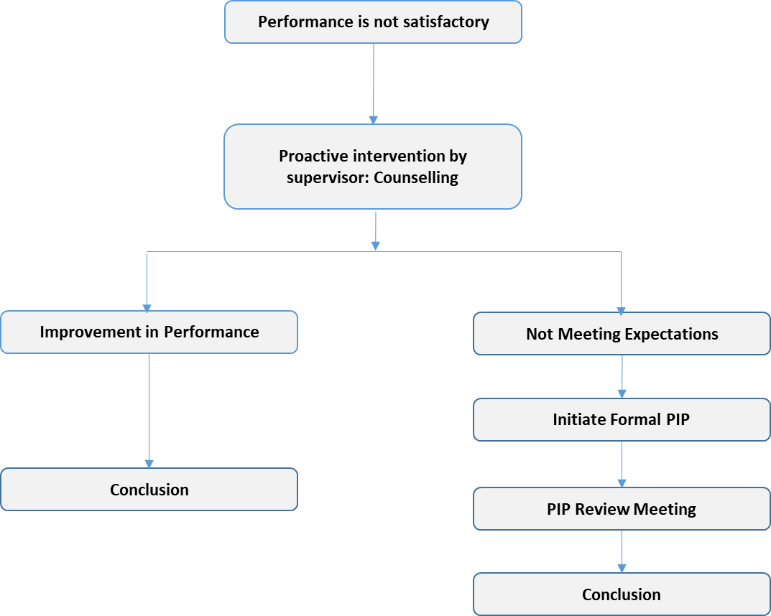
 | Employee | Supervisor | CSD/DM | LOB | HRBP
Communication of PIP | I | R | I | I | A
Initiating PIP | I | A | C | I | C
Weekly Review and documentation | R | A | I | I | I
Final Review | R | A | C | I | I
Conclusion - Recommended Actions | I | C | A | C | C
Legend | R - Responsible, A- Accountable, C -Consulted and I - Informed

Process Flow

ABC Company Document

Frequently asked questions (FAQ’s)

What is a Performance Improvement Plan?
A: A Performance Improvement Plan (PIP) is the performance document which identifies performance in which the employee needs improvement. It includes an action plan which identifies what the employee must do and how the supervisor will help the employee to improve performance during the performance management period.

When is a PIP issued?
A: A PIP may be issued when an employee’s attendance, discipline or attitude/ behaviour is identified by the manager to be unsatisfactory or when an employee is rated as below expectations and substantially below expectations in the annual PMS, the HRBP will initiate the PIP in the portal and the reporting manager will input the goals for PIP, to provide an opportunity to improve the performance to meet expectations in the consequent cycles.

Can a manager initiate PIP to an employee due to personal reasons?
A: Any request to initiate PIP by manager will be closely monitored by HR Business partner, The HR Business Partner gathers feedback and critically evaluates whether PIP shall be initiated.

If an employee is on PIP, does that mean she/he will be terminated?
A: No, the purpose of PIP is to improve the performance of the employee. A PIP is strategy to help employee whose performance has been lacking but have potential and motivation to remain a strong team player. It includes an action plan which identifies what the employee must do and how the supervisor will help the employee to improve performance during the performance management period.

How long does a PIP last?
A: A PIP may be issued for a 30, 60, or 90days period, at the supervisor’s discretion. The maximum
time for a PIP is 90 days.

What happens if an employee successfully completes the PIP goal?
A: If the employee performance meets the expectations outlined on the PIP and is maintained for the duration of the performance management period, then there will be no further action required. Manager provides the overall closure comments/summary in the portal and the same will be communicated to the Employee.

ABC Company Document

How will Employee be informed on initiation of PIP?
A: Formal Discussion is initiated along with HRBP and Manager, during the discussion all the areas of improvement are discussed and the need for PIP is announced.

------------- End of the Document ------------

.

